Attachment
F.1 General Information of Project

Name of project
Location
Main purpose
Reservoir Capacity (10⁶m³)
Installed Capacity (MW)
Company involved | Owner
Company involved | Designer
Company involved | Dam project contractor
Company involved | Consultant
Company involved | Manufactures and assembly firms
RCC Dam | Type |  | □RCCGP; □RCCVA;  □CMD (Hardfill, CSG included)  Other:
RCC Dam | Height(m)
RCC Dam | Crest width(m)
RCC Dam | Crest length(m)
RCC Dam | Crest elevation (m)
RCC Dam | Volume (10⁶m³) |  | Total Volume:  RCC Volume:
RCC Dam | Slope | Upstream
RCC Dam | Slope | Downstream
RCC Dam | Facings | Upstream
RCC Dam | Facings | Downstream
RCC Dam | Cementitious content | Cement (kg/m³)
RCC Dam | Cementitious content | Flyash(kg/m³)
RCC Dam | Placement | Layers (mm)
RCC Dam | Placement | Lift (mm)
Construction | Project Started
Construction | Project Finished
Construction | RCC dam Started
Construction | RCC dam Finished
Construction | The maximum monthly intensity of RCC
Photos of project

F.2 Innovative technologies

- Introduction of the project

- Major innovative technologies used in the project

- Performance of the project

- Technical achievements and Prizes ever achieved

- Environmental and social aspects and local contributions of the project

F.3 Application Company Information

Company Name |  | Contact Person
Tel. No./Mobile No. |  | Fax No.
Email Address |  | Postal Address
Will attend the symposium to accept the award if the project has been awarded |  | □Yes □ No
Name of the representative if it differs from the contact person
No. of the Set of Brand and Certificate required

Company Name |  | Contact Person
Tel. No./Mobile No. |  | Fax No.
Email Address |  | Postal Address
Will attend the symposium to accept the award if the project has been awarded |  | □Yes □ No
Name of the representative if it differs from the contact person
No. of the Set of Brand and Certificate required

Company Name |  | Contact Person
Tel. No./Mobile No. |  | Fax No.
Email Address |  | Postal Address
Will attend the symposium to accept the award if the project has been awarded |  | □Yes □ No
Name of the representative if it differs from the contact person
No. of the Set of Brand and Certificate required
…
N.B. Each awarded project will receive only one set for free and will be charged if more copies needed. €1,000 for one copy, including one Brand and one Certificate, is required for each representative to cover the expenses of nominating, evaluating, brand and certificate designing and making, and other aspects related.

If no representatives of an accepted project are present, it will be considered as renouncing the award.
Please submit the above materials to the secretariat of the Symposium before July 31st. It is suggested to submit the documents to us through Wechat.
Contact: Dr. Aili LI
Tel: +86-10-68585310; Fax: +86-10-68712208
Wechat ID: ailisi090968; Email: chincold-en@vip.126.com
WeChat Instructions
Install Wechat
- Search “Wechat” on App Store (for IOS) or Google Play (for Android) application, then tap “GET ” button for install Wechat to your device.

Register and Login Wechat
- Tab “Sign up” button, type your full name, country code, mobile number and password.
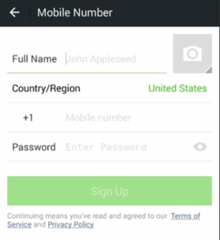

Add Contacts on Wechat
- Tap “+” at the top right corner, and then Tap the coin “Add Contacts”
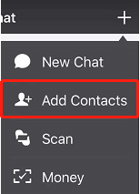
- Enter the Contact’s Wechat ID and then add him as your Wechat friend. The contact of CHINCOLD is Dr. Aili LI, and her Wechat ID is “ailisi090968”.

Make Voice Chat with Your Friends
- On chat screen, you’ll find signal icon on button left hand corner, tab it.
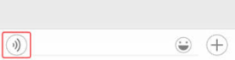
- You can see “Hold to Talk” button, hold it to start recording a voice. Release the button to send your voice.
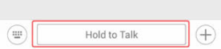

How to Share Images on Wechat
- You can share the images in your device, tab the “+” button and Tap the Images icon button, then pick and send images.
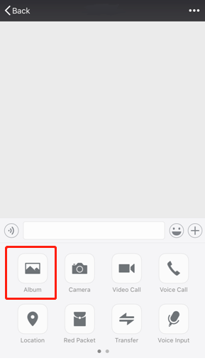

Make a Voice and Video Call on Wechat
- You can share the images in your device, tab the “+” button and Tap the Voice and Video Call icon button.



